5.3 Incident Creation
Create a test incident/ticket in ServiceNow with the required information.

Ticket Details
Field | Example
Number | Automatically generated
Caller | Selected user
Category | Selected category
Short Description Ticket issue description
Assignment Group Automatically assigned / configured group
State New / appropriate state
Image:

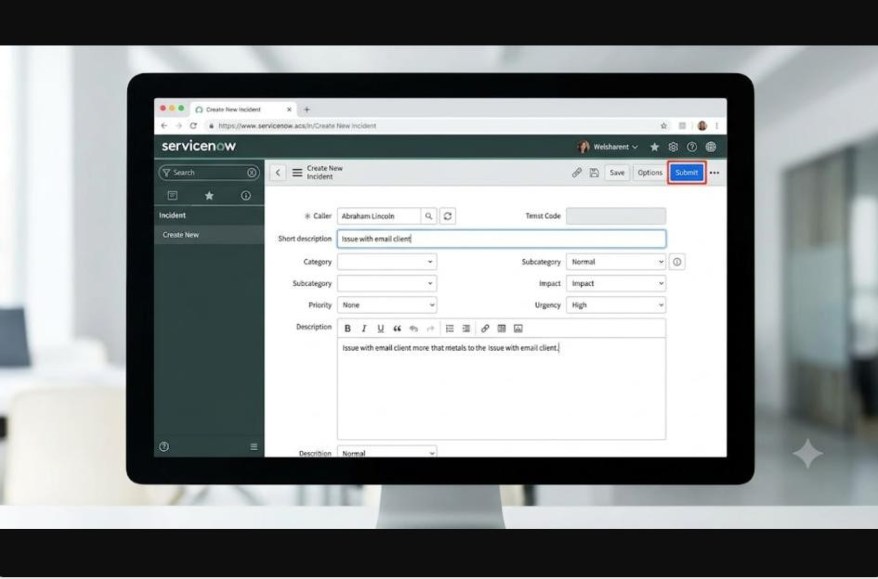

Caption:
Figure 6: Creating an Incident Ticket

